
REPUBLIC OF CAMEROON
PEACE-WORK-FATHERLAND
UNIVERSITY OF BUEA
FACULTY OF ENGINEERING AND TECHNOLOGY

DEPARTMENT OF COMPUTER ENGINEERING
CEF 440: INTERNET PROGRAMMING AND MOBILE PROGRAMMING

TASK 5: UI DESIGN AND IMPLEMENTATION

COURSE INSTRUCTOR: Dr. VALERY NKEMENI
Presented by: GROUP 20
NAME | MATRTICLE
TEBOH MANOIELLA | FE23A167
EBONG THIERRY | FE23A039
EBONG VALITINE | FE23A038
LUIGI-GONZAGA M. FONKENG | FE23A084

CHAPTER 5: UI DESIGN AND IMPLEMENTATION

Table of Contents
5.1 Introduction
5.2 App Identity
5.3 Design Objectives
5.4 Visual Design
5.5 Frontend Architecture
5.6 Screen Design and Implementation
5.7 User Experience Considerations
5.8 Responsive and Mobile Design Considerations
5.9 Frontend Implementation
5.10 Testing and Validation
5.11 Summary

5.1 Introduction
The CellScope user interface was designed to provide an intuitive and efficient environment for collecting cellular network measurements. Because the application targets users operating in real-world environments, including moving vehicles and areas with poor connectivity, the interface emphasizes clarity, simplicity, responsiveness, and offline usability. The UI serves as the bridge between users and the network measurement services provided by the system.
This chapter describes the design philosophy, visual identity, frontend architecture, implementation technologies, and screen-level design decisions adopted during the development of CellScope.

5.2 App Identity
Application Name: CellScope
Purpose:
CellScope is a crowdsensed drive test application that enables users to collect network coverage measurements using smartphones. The application gathers network metrics and location information to support coverage assessment and future coverage prediction.
Target Users:
• Telecommunications engineers
• Researchers
• Students
• Mobile network subscribers
• Coverage analysts
Core Functionalities:
• User authentication
• Measurement collection
• GPS acquisition
• Offline storage
• Synchronization
• Coverage visualization
• Profile management

5.3 Design Objectives
Usability: Enable efficient operation with minimal training.
Simplicity: Present only information necessary for measurement collection and management.
Accessibility: Use readable typography, clear colour contrast, and large touch targets.
Consistency: Maintain uniform navigation, styling, and interaction patterns.
Offline-First Design: Ensure measurements can be collected and viewed without internet access.
Scalability: Support future expansion such as AI-based coverage prediction and advanced analytics.

5.4 Visual Design
Design Language:
CellScope adopts a professional, engineering-oriented design inspired by modern network-monitoring applications.
Colour Scheme:
• Blue – primary actions and navigation
• Green – strong signal and successful operations
• Yellow/Orange – warnings and pending actions
• Red – weak signal and errors
• White/Grey – content surfaces and backgrounds
Typography:
The interface uses a clear hierarchy of headings, labels, and body text to improve readability.
Icons:
Location, synchronization, signal, account, history, and navigation icons are used throughout the application to improve recognition and reduce cognitive effort.
Layout Strategy:
A card-based layout groups related information and improves mobile usability.

5.5 Frontend Architecture
Technology Stack:
• React
• TypeScript
• Vite
• Tailwind CSS
• Capacitor
Architectural Approach:
The frontend follows a component-based architecture. Reusable components such as cards, buttons, dialogs, status indicators, and form controls are implemented once and reused throughout the application.
Routing:
Client-side routing controls navigation between authentication, dashboard, measurement, synchronization, mapping, and profile modules.
State Management:
Application state manages authentication, measurement sessions, synchronization status, and user preferences.

5.6 Screen Design and Implementation

Splash Screen

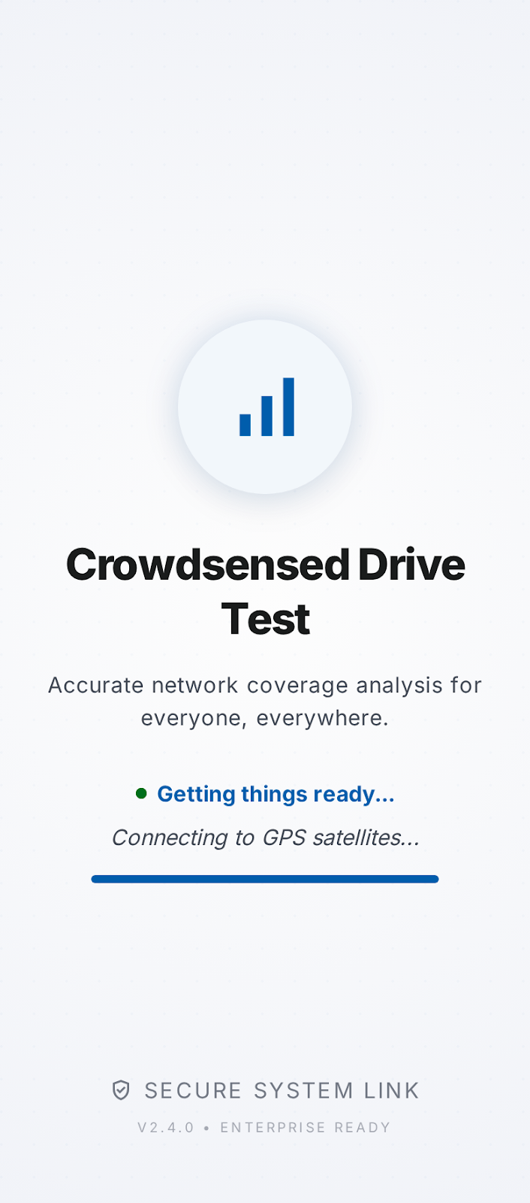
Purpose:
The Splash Screen supports a specific stage of the user workflow and was designed to ensure efficient interaction and task completion.
Interface Components:
Describe all buttons, forms, cards, indicators, icons, menus, and information panels displayed on this screen.
User Interactions:
Explain how users interact with the available controls and how the system responds.
Navigation Relationships:
Identify how users arrive at this screen and where they can navigate next.
Design Considerations:
Discuss usability, consistency, accessibility, information hierarchy, and mobile optimization decisions.
Implementation Notes:
Explain how React components, TypeScript logic, Tailwind CSS styling, and Capacitor mobile deployment contribute to this screen's functionality.

Login Screen

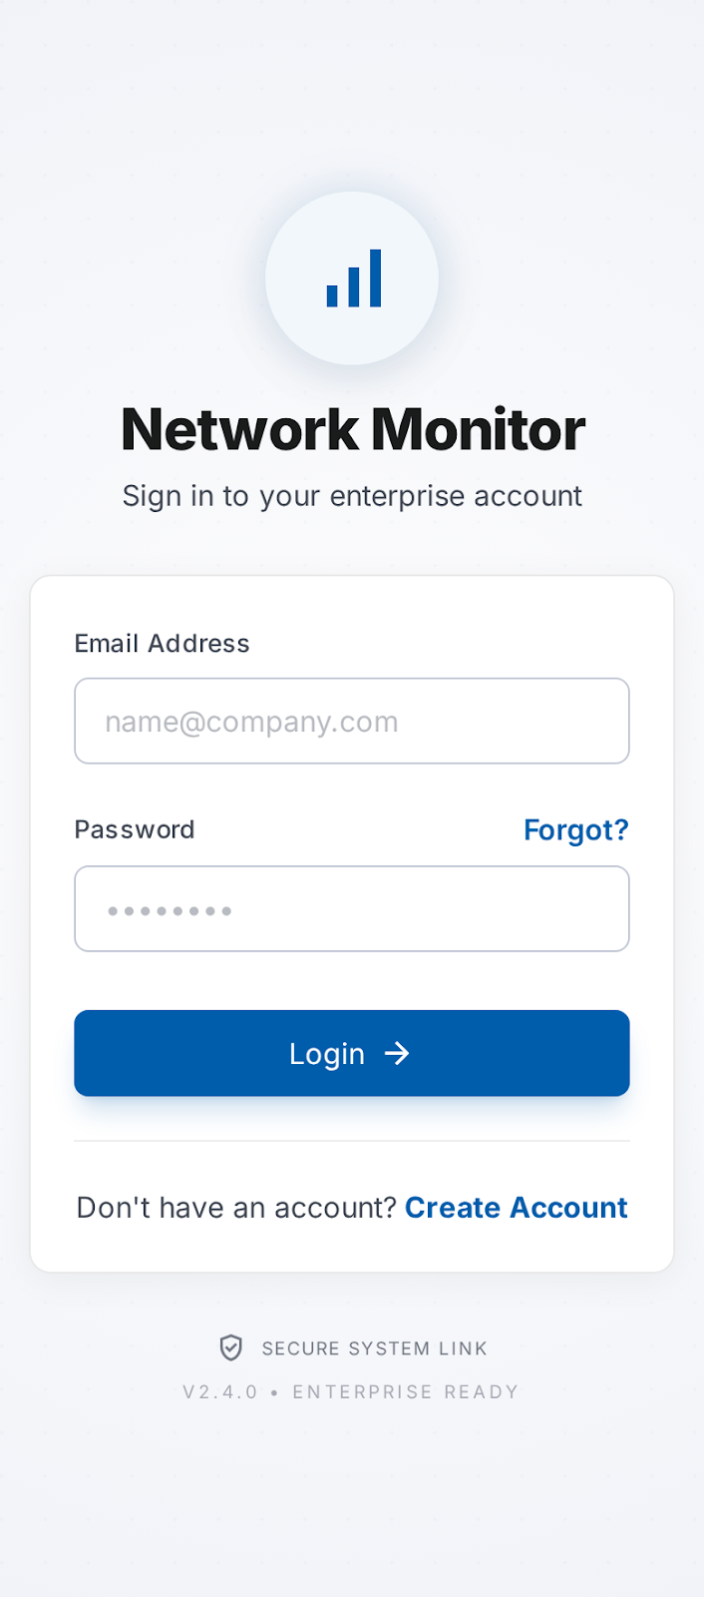
Purpose:
The Login Screen supports a specific stage of the user workflow and was designed to ensure efficient interaction and task completion.
Interface Components:
Describe all buttons, forms, cards, indicators, icons, menus, and information panels displayed on this screen.
User Interactions:
Explain how users interact with the available controls and how the system responds.
Navigation Relationships:
Identify how users arrive at this screen and where they can navigate next.
Design Considerations:
Discuss usability, consistency, accessibility, information hierarchy, and mobile optimization decisions.
Implementation Notes:
Explain how React components, TypeScript logic, Tailwind CSS styling, and Capacitor mobile deployment contribute to this screen's functionality.

Registration Screen

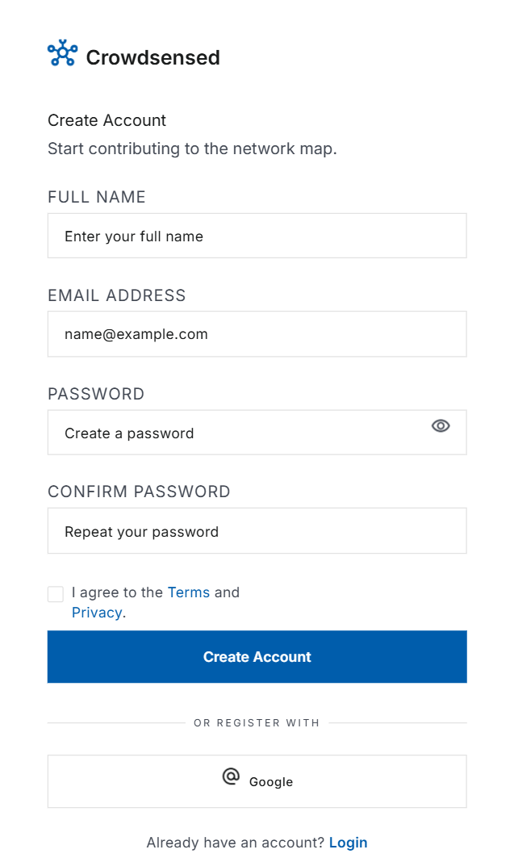

Purpose:
The Registration Screen supports a specific stage of the user workflow and was designed to ensure efficient interaction and task completion.
Interface Components:
Describe all buttons, forms, cards, indicators, icons, menus, and information panels displayed on this screen.
User Interactions:
Explain how users interact with the available controls and how the system responds.
Navigation Relationships:
Identify how users arrive at this screen and where they can navigate next.
Design Considerations:
Discuss usability, consistency, accessibility, information hierarchy, and mobile optimization decisions.
Implementation Notes:
Explain how React components, TypeScript logic, Tailwind CSS styling, and Capacitor mobile deployment contribute to this screen's functionality.

Dashboard Screen

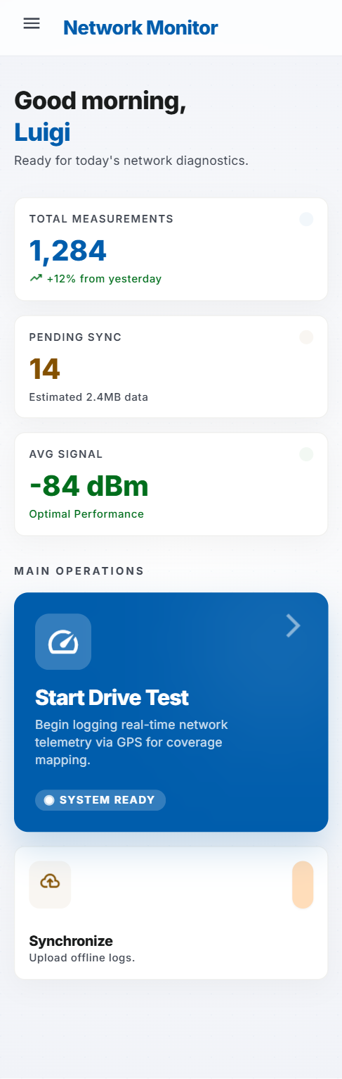
Purpose:
The Dashboard Screen supports a specific stage of the user workflow and was designed to ensure efficient interaction and task completion.
Interface Components:
Describe all buttons, forms, cards, indicators, icons, menus, and information panels displayed on this screen.
User Interactions:
Explain how users interact with the available controls and how the system responds.
Navigation Relationships:
Identify how users arrive at this screen and where they can navigate next.
Design Considerations:
Discuss usability, consistency, accessibility, information hierarchy, and mobile optimization decisions.
Implementation Notes:
Explain how React components, TypeScript logic, Tailwind CSS styling, and Capacitor mobile deployment contribute to this screen's functionality.

Drive Test Screen

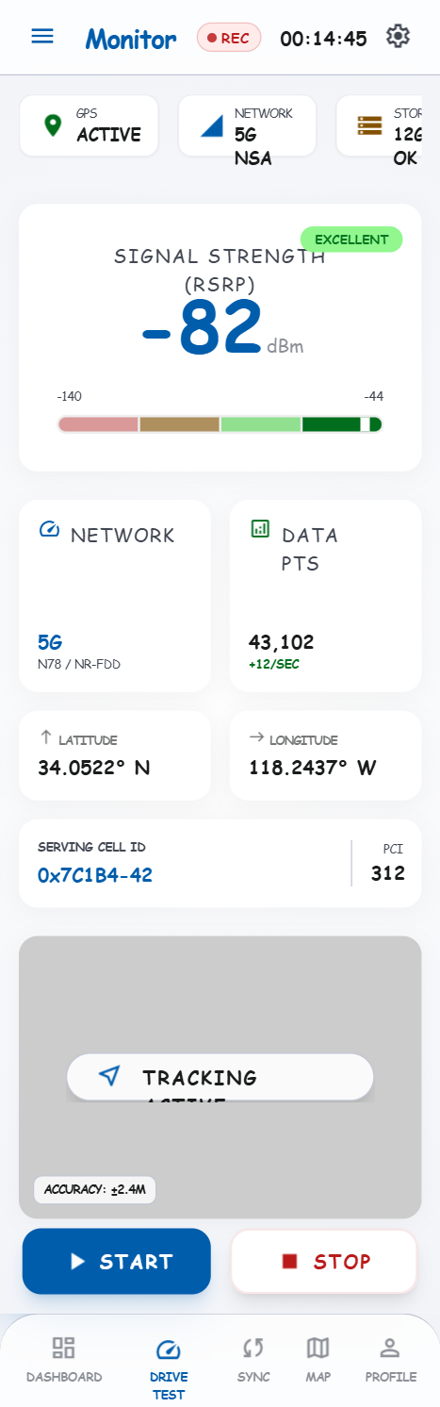Purpose:
The Drive Test Screen supports a specific stage of the user workflow and was designed to ensure efficient interaction and task completion.
Interface Components:
Describe all buttons, forms, cards, indicators, icons, menus, and information panels displayed on this screen.
User Interactions:
Explain how users interact with the available controls and how the system responds.
Navigation Relationships:
Identify how users arrive at this screen and where they can navigate next.
Design Considerations:
Discuss usability, consistency, accessibility, information hierarchy, and mobile optimization decisions.
Implementation Notes:
Explain how React components, TypeScript logic, Tailwind CSS styling, and Capacitor mobile deployment contribute to this screen's functionality.

Measurement History Screen

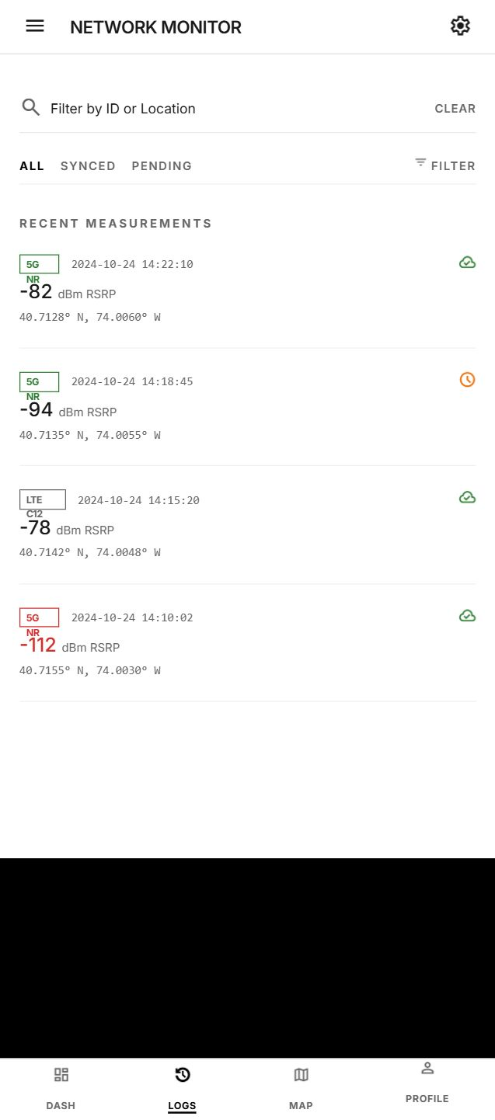Purpose:
The Measurement History Screen supports a specific stage of the user workflow and was designed to ensure efficient interaction and task completion.
Interface Components:
Describe all buttons, forms, cards, indicators, icons, menus, and information panels displayed on this screen.
User Interactions:
Explain how users interact with the available controls and how the system responds.
Navigation Relationships:
Identify how users arrive at this screen and where they can navigate next.
Design Considerations:
Discuss usability, consistency, accessibility, information hierarchy, and mobile optimization decisions.
Implementation Notes:
Explain how React components, TypeScript logic, Tailwind CSS styling, and Capacitor mobile deployment contribute to this screen's functionality.

Synchronization Screen

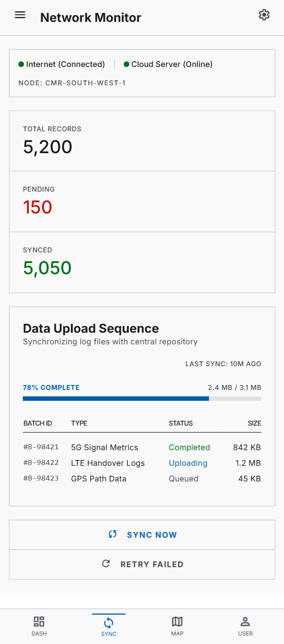Purpose:
The Synchronization Screen supports a specific stage of the user workflow and was designed to ensure efficient interaction and task completion.
Interface Components:
Describe all buttons, forms, cards, indicators, icons, menus, and information panels displayed on this screen.
User Interactions:
Explain how users interact with the available controls and how the system responds.
Navigation Relationships:
Identify how users arrive at this screen and where they can navigate next.
Design Considerations:
Discuss usability, consistency, accessibility, information hierarchy, and mobile optimization decisions.
Implementation Notes:
Explain how React components, TypeScript logic, Tailwind CSS styling, and Capacitor mobile deployment contribute to this screen's functionality.

Coverage Map Screen

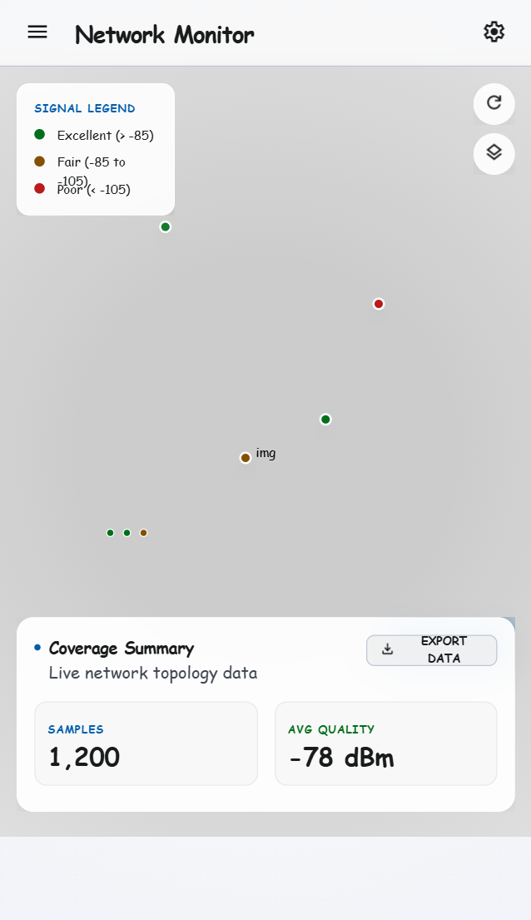
Purpose:
The Coverage Map Screen supports a specific stage of the user workflow and was designed to ensure efficient interaction and task completion.
Interface Components:
Describe all buttons, forms, cards, indicators, icons, menus, and information panels displayed on this screen.
User Interactions:
Explain how users interact with the available controls and how the system responds.
Navigation Relationships:
Identify how users arrive at this screen and where they can navigate next.
Design Considerations:
Discuss usability, consistency, accessibility, information hierarchy, and mobile optimization decisions.
Implementation Notes:
Explain how React components, TypeScript logic, Tailwind CSS styling, and Capacitor mobile deployment contribute to this screen's functionality.

Profile and Settings Screen

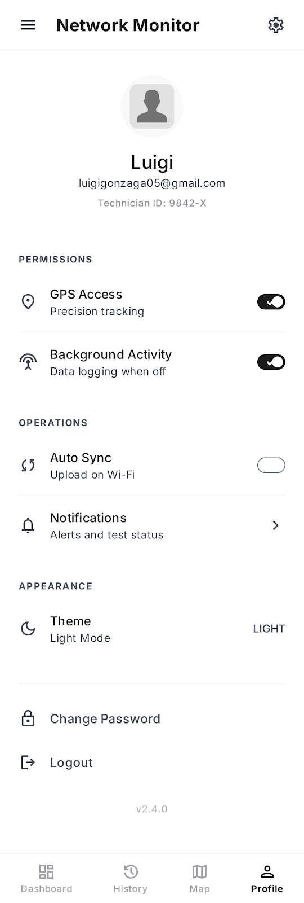
Purpose:
The Profile and Settings Screen supports a specific stage of the user workflow and was designed to ensure efficient interaction and task completion.
Interface Components:
Describe all buttons, forms, cards, indicators, icons, menus, and information panels displayed on this screen.
User Interactions:
Explain how users interact with the available controls and how the system responds.
Navigation Relationships:
Identify how users arrive at this screen and where they can navigate next.
Design Considerations:
Discuss usability, consistency, accessibility, information hierarchy, and mobile optimization decisions.
Implementation Notes:
Explain how React components, TypeScript logic, Tailwind CSS styling, and Capacitor mobile deployment contribute to this screen's functionality.

5.7 User Experience Considerations
The CellScope user experience was designed around minimizing user effort while maximizing operational efficiency. Key considerations include:
• Simple navigation paths.
• Consistent visual patterns.
• Immediate feedback for user actions.
• Clear status indicators.
• Minimal data entry requirements.
• Efficient access to core functionality.
• Support for offline workflows.
• Reduced cognitive load during field operations.
These considerations ensure users can focus on data collection rather than learning complex application behaviour.

5.8 Responsive and Mobile Design Considerations
CellScope was designed primarily for Android mobile devices. Responsive design principles were applied to ensure compatibility across different screen sizes and resolutions.
Considerations include:
• Flexible layouts.
• Touch-friendly controls.
• Dynamic content scaling.
• Portrait orientation optimization.
• Efficient use of screen space.
• Consistent appearance across devices.
Tailwind CSS utilities assist in maintaining responsiveness and layout consistency.

5.9 Frontend Implementation
The frontend implementation followed an incremental development process:
Phase 1: Wireframe Design
Phase 2: Component Development
Phase 3: Page Construction
Phase 4: Routing Configuration
Phase 5: Styling Integration
Phase 6: Service Integration
Phase 7: Mobile Packaging
Key React Components:
• Authentication Components
• Dashboard Components
• Measurement Cards
• History Components
• Synchronization Components
• Map Components
• Profile Components
The implementation emphasizes maintainability, scalability, and code reuse.

